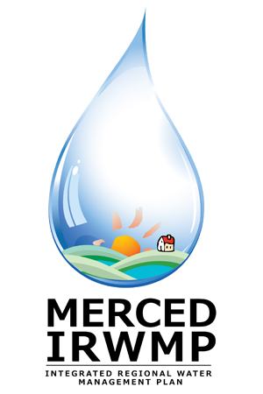

Merced Integrated Regional Water Management (IRWM) Plan
Regional Advisory Committee Meeting #13
Tuesday May 28, 2013
2:00 pm – 4:30 pm
The Sam Pipes Room
1st floor of the Civic Center (City Hall)
678 W. 18th Street
Merced, CA 95340

- Introductions and Overview 15 Min
- DWR Update 5 Min
- RAC Activities and Materials 10 Min
- IRWM Plan Review 60 Min
- Governance Update 20 Min
- Water Resources Model Update 20 Min
- Next Steps 10 Min
- Public Comment 10 Min

